**LAB # 01**

## AN OVERVIEW OF NETWORKING

**OBJECTIVE**

Introduction to Networks with Cisco IOS CLI. Overview of real time and simulation mode.

**HOME ASSIGNMENT**

## Q1: Briefly describe any four (4) network types.

1. LAN(Local Area Network)

Local Area Network is a group of computers connected to each other in a small area such as building, office.LAN is used for connecting two or more personal computers through a communication medium such as twisted pair, coaxial cable, etc.It is less costly as it is built with inexpensive hardware such as hubs, network adapters, and ethernet cables.The data is transferred at an extremely faster rate in Local Area Network.Local Area Network provides higher security.

# PAN(Personal Area Network)

Personal Area Network is a network arranged within an individual person, typically within a range of 10 meters.Personal Area Network is used for connecting the computer devices of personal use is known as Personal Area Network.**Thomas Zimmerman** was the first research scientist to bring the idea of the Personal Area Network.Personal Area Network covers an area of **30 feet**.Personal computer devices that are used to develop the personal area network are the laptop, mobile phones, media player and play stations.

# MAN(Metropolitan Area Network)

A metropolitan area network is a network that covers a larger geographic area by interconnecting a different LAN to form a larger network.Government agencies use MAN to connect to the citizens and private industries.In MAN, various LANs area connected to each other through a telephone exchange line.The most widely used protocols in MAN are RS-232, Frame Relay, ATM, ISDN, OC-3, ADSL, etc.It has a higher range than Local Area Network(LAN).

# WAN(Wide Area Network)

A Wide Area Network is a network that extends over a large geographical area such as states or countries. A Wide Area Network is quite bigger network than the LAN.A Wide Area Network is not limited to a single location, but it spans over a large geographical area through a telephone line, fibre optic cable or satellite links. The internet is one of the biggest WAN in the world.A Wide Area Network is widely used in the field of Business, government, and education.

### Q2: Write description of any three commands of ‘User Mode”?

* + **Clock:** To set clock functions or update the calendar, use the clock EXEC command. (Examples) clock set 13:32:00 01 February 2005
  + **enable**: To enter user privileged mode.
  + **copy disk:** To copy the configuration or image data from a disk to a remote.

### Q3**:** Write description of any three commands of ‘Privileged Mode”

* + **reload**: Use the **reload command** to **reload** the switch immediately.
  + **configure**: To enter global configuration mode.
  + **debug** : It displays information about the **Cisco** device operations, generated or received traffic, and any error messages.

Q4 : What is the common information listed under the **IP** section of **PDU Details** as compared to the information listed under the **OSI Model** tab? With which layer is it associated?

* + The common information listed under the ip section of pdu details as compared to the information listed under the OSI model tab is Packet Tracer..

**---------------------------------------------------------------------------------------------------------------------**

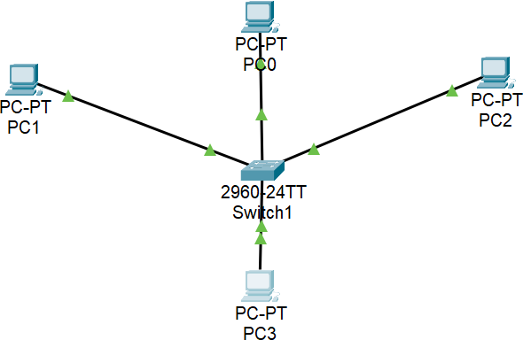

**CLI:**

### Switch1#config terminal

Enter configuration commands, one per line. End with CNTL/Z. Switch1(config)#line console 0

Switch1(config-line)#password cisco111 Switch1(config-line)#^Z

Switch1#

%SYS-5-CONFIG_I: Configured from console by console

Thank you for using [www.freepdfconvert.com](http://www.freepdfconvert.com/) service!

Only two pages are converted. Please Sign Up to convert all pages. <https://www.freepdfconvert.com/membership>